Ant Colony System：A Cooperative Learning Approach to Traveling Salesman Problem
Marco Dorigo and Luca Maria Gambardella
IEEE Transaction on Evolutionary Computation, Vol. 1, NO. 1, April 1997,
pp. 53-66
- Introduction
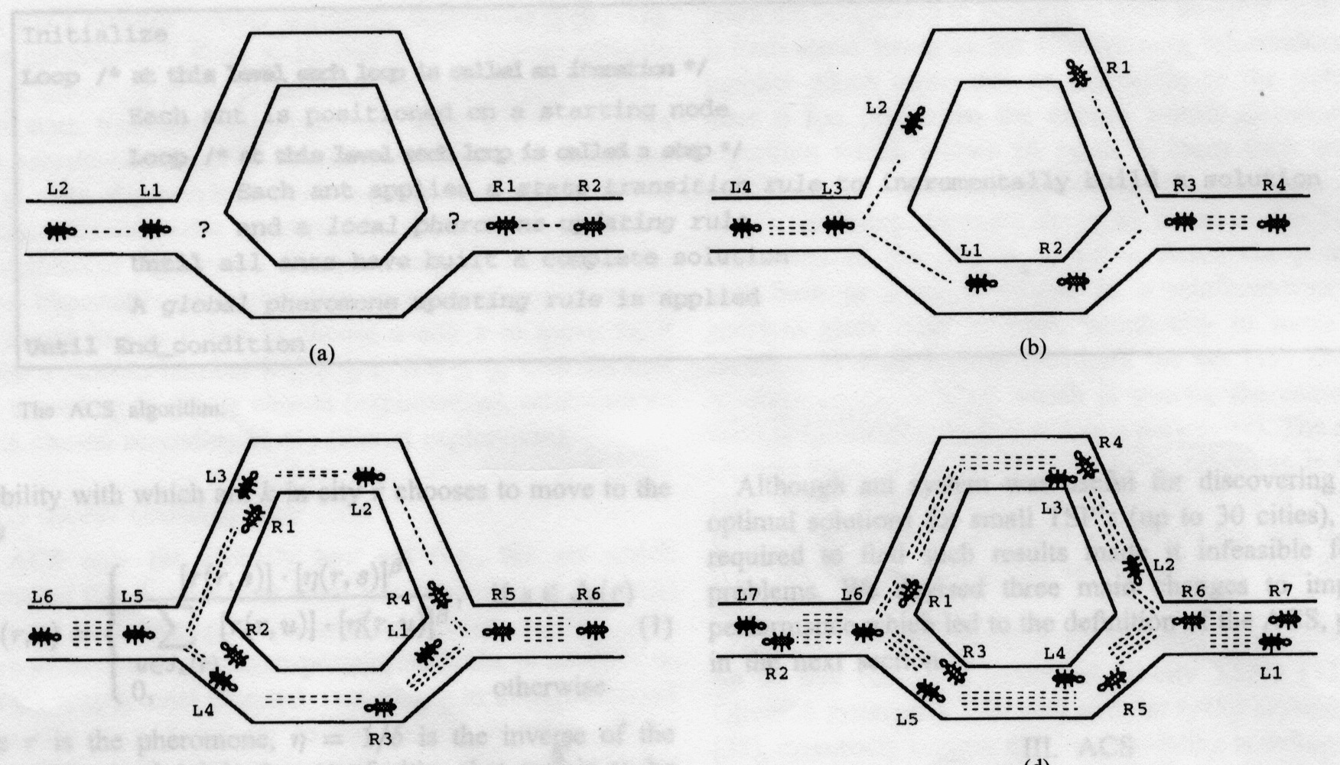
- Background
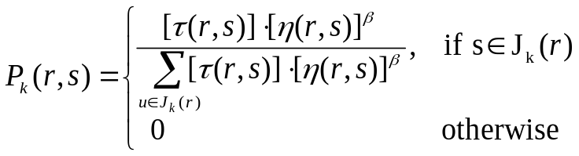
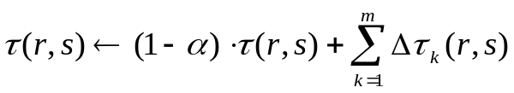

3. ACS
- ACS State Transition Rule
- ACS Global Updating Rule
- ACS Local Updating Rule
- ACS Parameter Settings

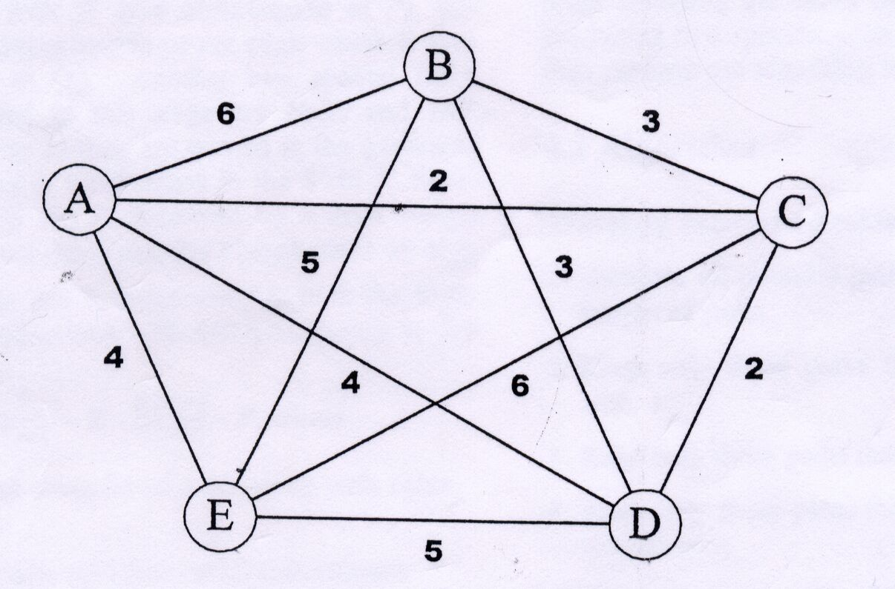
Created by: Ing-Jer Liao
Date: May 16, 2002

